CIS1513 Database Design and SQL

Global_Fast_Foods_Step_2 (Creating 4 more tables)

PART 1- Finish the Physical Layout sheets for SHIFT_ASSIGN entity, then create code for the table and run it in SQL Oracle Developer.

NOTE: Shift Assignment (barred relationships PK’s and Foreign Keys)

What’s the Primary key(composite) of SHIFT_ASSIGN?

_____________________________________________________

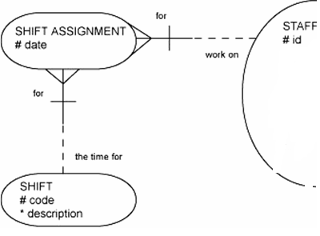
We already created SHIFT & STAFF
(in previous assignment _STEP 1)

#SHIFT_DATE
Already done in Step 1

Already done in Step 1

SHIFT
# SHIFT_ID N(5)
* SHIFT_DESC V2(15)

Name: SHIFT_ASSIGN
Key type | optionality  ( * or o) | Column Name | Column Data Type  (Varchar2,number,date)
PK,FK |  | STAFF_ID | Number(5)
PK,FK |  | SHIFT_ID | Number(5)
PK |  | SHIFT_DATE | DATE
Notes on Foreign Key

CONSTRAINT NAME_OF_CONSTRAINT FOREIGN KEY (COLUMN)
REFERENCES PARENT(PARENTs_PK)

PART 2 - Finish the Physical Layout sheets for the following, Use ERD’s below to help you.

ORDERS/ORDERLINE/FOODITEMS
(Then create code for the table and run it in SQL Oracle Developer)
ORDERS
Key type  (PK,FK) | Optionality  ( * or o) | Column Name | Column Data Type  Varchar2,number,date
PK | * | ORDER_ID | NUMBER(6)
 | * | ORDER_DATE | DATE
FK | * | STAFF_ID | NUMBER(5)

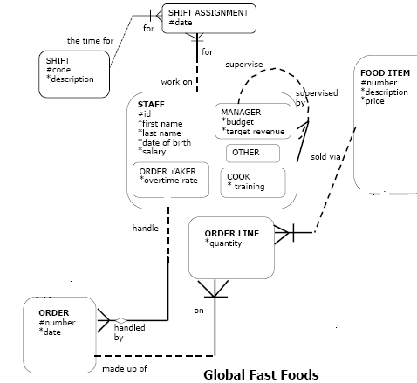
FOOD_ITEMS
Key type  (PK,FK) | Optionality  ( * or o) | Column Name | Column Data Type  (Varchar2,number,date)
PK |  | FOOD_ID | NUMBER(4)
 | * | FOOD_DESCRIPTION | VARCHAR2(20)
 | * | PRICE | NUMBER(5,2)
ORDER_ITEMS(same as orderline)
Key type  (PK,FK) | * or o | Column name | Column Data Type  (Varchar2,number,date)
PK,FK | * | ORDER_ID | NUMBER
PK,FK | * | FOOD_ID | NUMBER
 | * | QTY | NUMBER(3)

